c

Interview Questions

Julia Chen

Be active!

Contents

1. Introduction 3

2. Java 3

2.1 Basic 3

2.1.1 String StringBuffer StringBuilder 3

2.1.2 Why String class has been made immutable in Java? 5

2.1.3 What is the difference between functional language and object oriented language. 5

2.2 Data Structure 6

2.5.1 HashSet TreeSet LinkedHashSet 6

2.5.2 HashTable HashMap LinkedHashMap HashSet 7

2.3 Java 8 8

2.3.1 Check Existing Students 8

2.4 Muti-thread 8

2.4.1 Check Existing Categories 8

2.5 JDBC 8

2.5.1 In JDBC connection when connection and statement is closed then can you access data from result set? 8

2.6 Servlet 8

3. Front-end 9

HTML 9

3.1.1 What are semantic tags in HTML? 9

3.1.2 New Semantic Elements in HTML5 9

CSS 10

3.1.3 Check Existing Students 10

JavaScript 10

3.1 Different ways of creating an Object in javascript 10

Using the Object() constructor: 10

Using Object.create() method: 11

Using the bracket's syntactig sugar: 11

Using a function constructor 11

Using the function constructor + prototype: 12

Using ES6 class syntax: 12

Singleton pattern: 12

3.2 Others 12

3.3.1 What is an object literal? 12

3.3.2 What is the difference call() & apply() vs bind()? 12

3.3.3 What is Callback function in JavaScript? 14

3.3.4 Promise 15

3.3.5 Closure 15

3.3.6 Module Pattern 15

JQuery 16

Ajax 16

Web Service 16

3.1.4 What is a web service? 16

3.1.5 What is the difference between RestFul and Soup? 16

4. Back-end 17

4.1 Optimization 17

4.1.1 How to optimize SQL join query 18

4.1.2 What makes SQL a nonprocedural language? 18

4.1.3 What is SQL Query Optimizing? 19

4.1.4 What is index in database 19

4.1.5 What is the Optimization Techniques in SQL Server? 19

4.2 Join 20

4.2.1 Inner Join 20

4.2.2 Left Outer Join 21

4.2.3 Right Outer Join 21

4.2.4 Full Outer Join 22

4.3 Normalization 22

4.3.1 First , second and third Normalization 22

4.3.2 What is a Functional Dependency? 23

4.3.3 What is a Transitive Dependency? 23

4.4 Others 24

4.4.1 What is trigger / stored procedure in MySQL? 24

4.4.2 Default port with MySQL and Oracle , mssql? 24

5. Spring 25

6. Hibernate 25

7. C++ 25

7.1 Edit Profile 25

8. Windows Admin 25

# What is Angular?

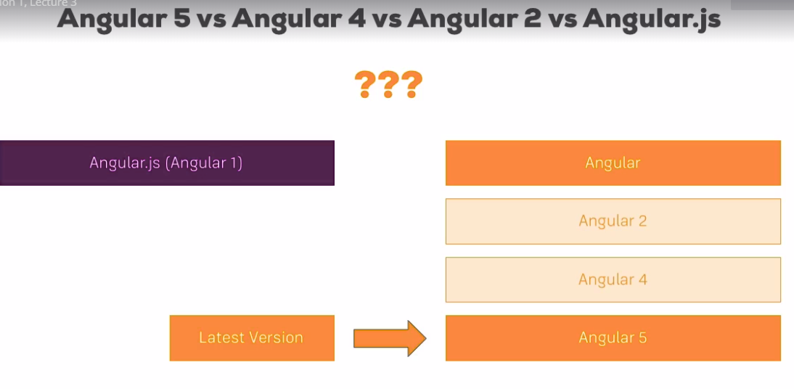

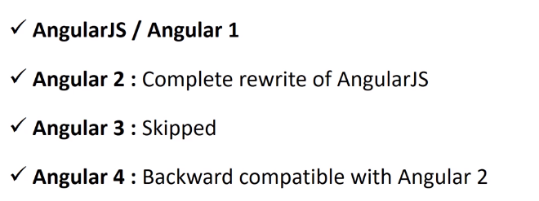

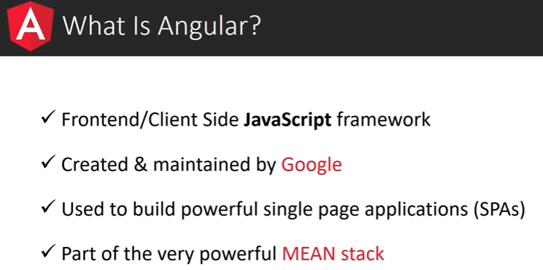

# Angular 5

## 5.1 Set up and the first app

### 1 Installation of Angular CLI and Node js

install nodejs

<https://nodejs.org/en/>

clone angular cli

https://cli.angular.io/

<https://github.com/angular/angular-cli>

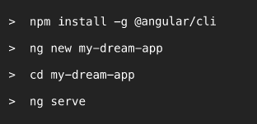

### 2 Nmp install –g @angular/cli

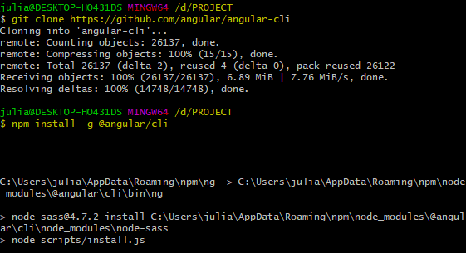

### 3 Ng new my-first-app

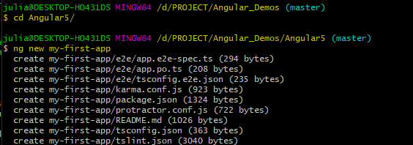

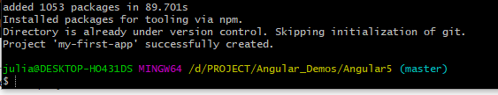

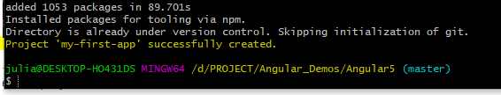

### 4 Ng serve

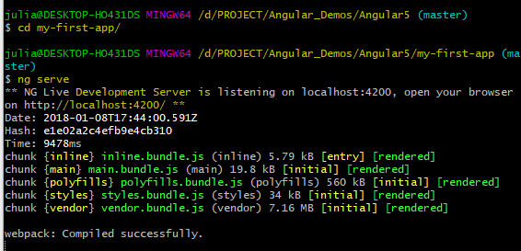

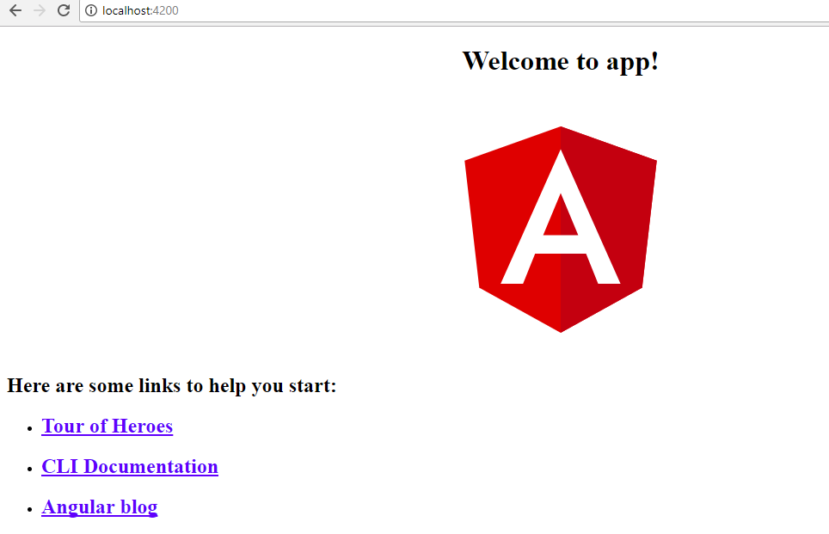

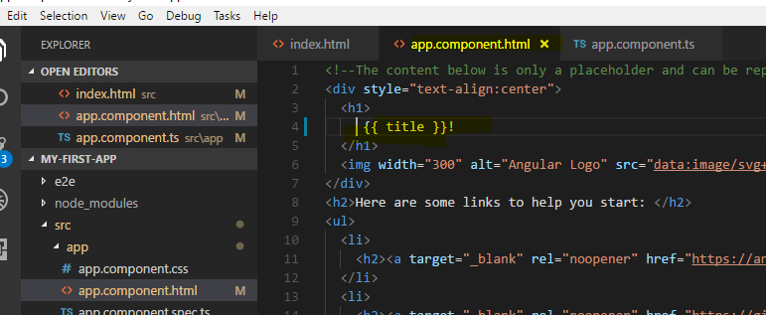

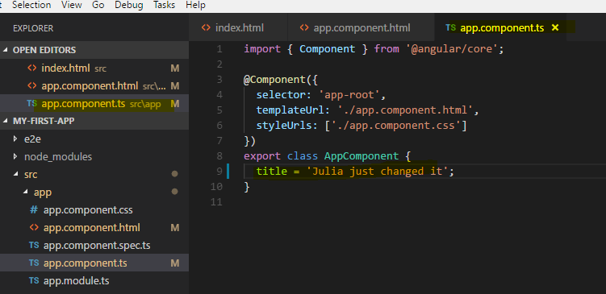

## 5.2 Add Bootstrap to Angular 5

### npm instll --save bootstrap

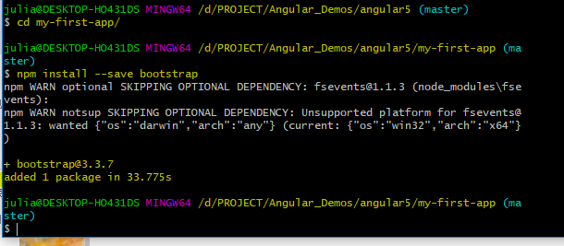"../node_modules/bootstrap/dist/css/bootstrap.min.css",

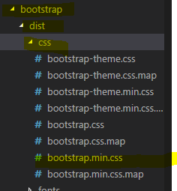

### ng serve

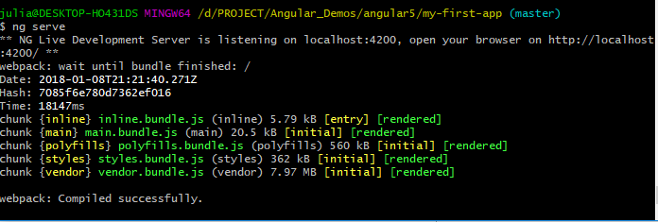

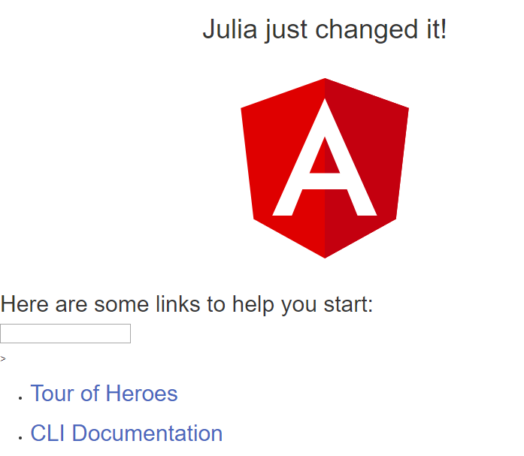

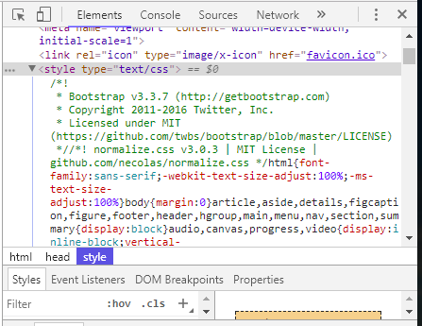

## 5.3 Generate Component by Command Line

### Ng generate component component-name --spec false

### ng g c component-name --spec false

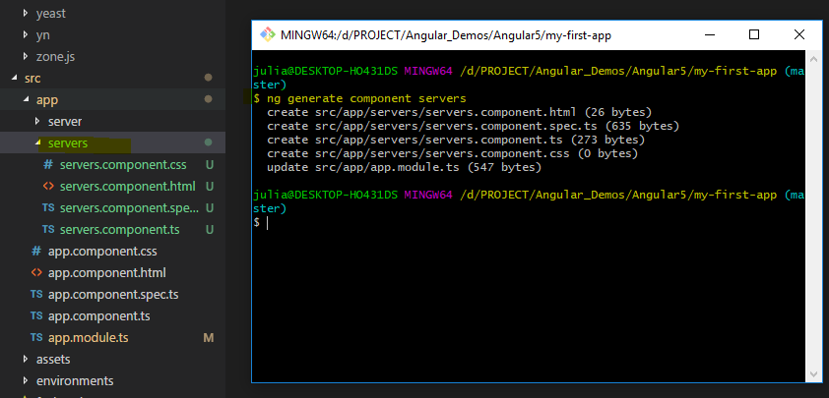

### ng g component pizza/pizza-order -m pizza

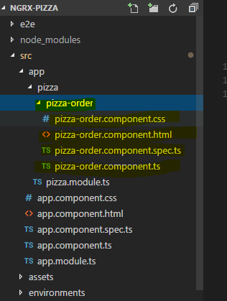

## 5.4 Generate Module by Command Line

### Ng g module pizza

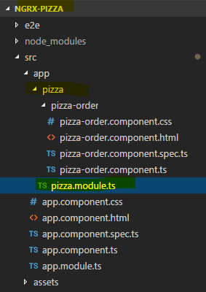

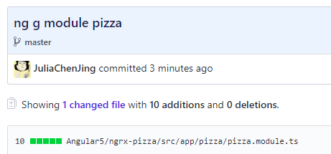

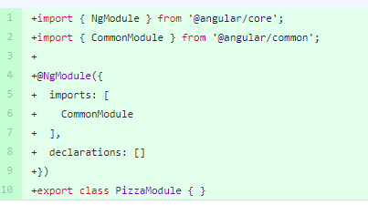

## 5.4 Run an existing App

Run "npm install" inside this project folder to install all dependencies.

### npm install

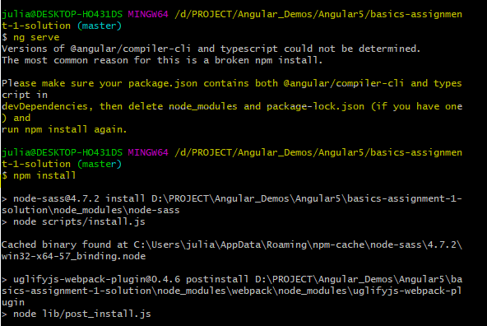

Make sure you use the latest version of the CLI (upgrade guide below)

Run "ng serve" to see the app in action (try "npm start" in case "ng serve" fails).

### ng serve/npm start

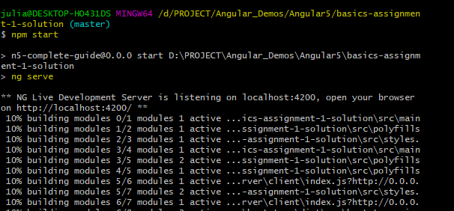

Feel free to compare it with your project code to spot any errors you might have.

## How to upgrade the CLI

-----------------------

Run the below commands - only use "sudo" on Mac/ Linux.

### sudo npm uninstall -g angular-cli @angular/cli



### npm cache clean --force

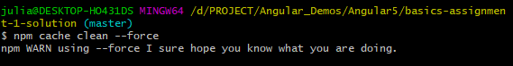

### sudo npm install -g @angular/cli

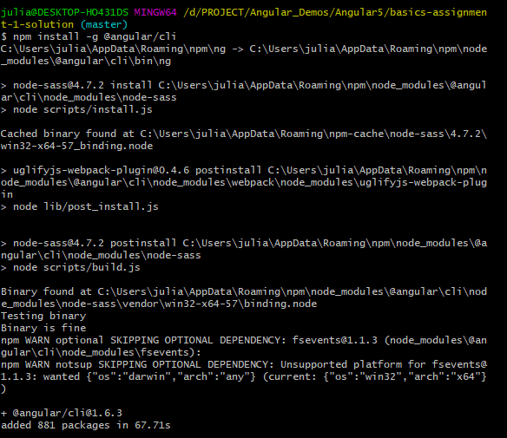

## 5.5 [“Port 4200 is already in use” when running the ng serve command](https://stackoverflow.com/questions/39091735/port-4200-is-already-in-use-when-running-the-ng-serve-command)

Open your cmd.exe as administrator,

then Find the PID of port 4200

### netstat -ano | findstr :4200

[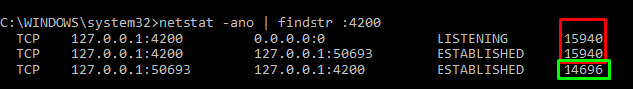](https://i.stack.imgur.com/mOSAv.png)

Here i have 3 PID :

* Red one is from "ng-serve" (127.0.0.1:4200) that LISTENING
* Green one is from "your browser"

kill only port 4200 (kill the red PID):

### taskkill /PID 15940 /F

note : kill the green one will only lead your browser closed by force.

[taskkill pid 15940](https://i.stack.imgur.com/ATfte.png)

now you can do "ng-serve" to start your angular app at the same port 4200

## 5.6 NGRX project

### [ng new ngrxProjectName](https://github.com/JuliaChenJing/Angular_Demos/commit/5e0fdbec1a91fa567d03a745b4df7d9102df2f8f)

[in the same path:](https://github.com/JuliaChenJing/Angular_Demos/commit/2673c9e6f5bd510da089ccc644460c232878553f" \o "in the same path:npm install @ngrx/store --save)

### [npm install @ngrx/store --save](https://github.com/JuliaChenJing/Angular_Demos/commit/2673c9e6f5bd510da089ccc644460c232878553f" \o "in the same path:npm install @ngrx/store --save)

In the lower path:

### npm install @ngrx/store

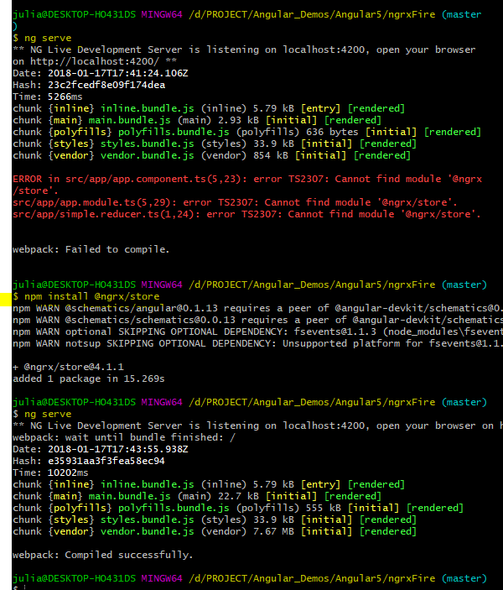

## 5.7 Can't bind to 'ngModel' since it isn't a known property of 'input'

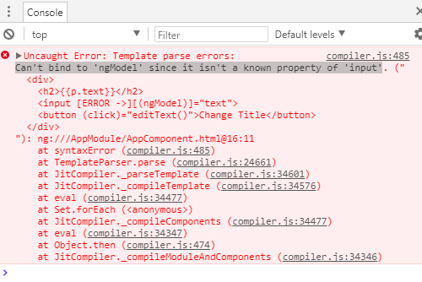

### Solution:

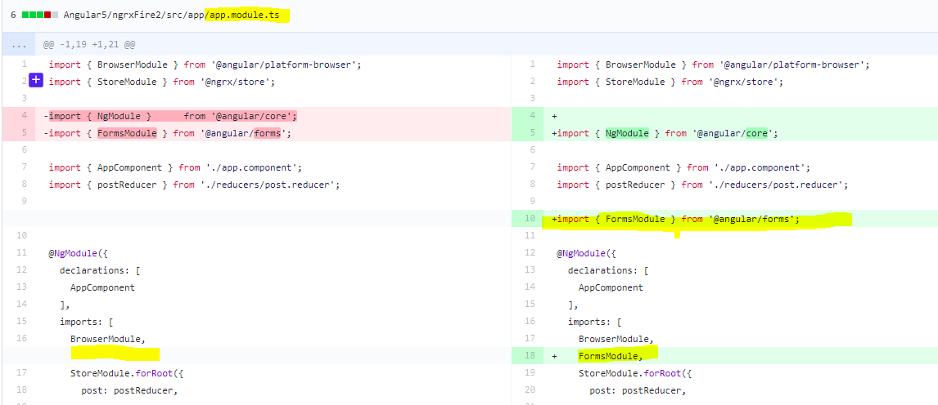

<https://stackoverflow.com/questions/43298011/angular-4-cant-bind-to-ngmodel-since-it-isnt-a-known-property-of-input/43298039>

# Angular JS

## 1.1 Introduction of Angular JS

AngularJS is a complete JavaScript framework for creating dynamic and interactive applications in HTML. Aside from being one of the hottest frameworks on the web, AngularJS is easy to learn yet powerful enough to help you develop complex single-page web applications. This learning path is specific to AngularJS and does not cover Angular 2 topics. Angular 2 was just finalized in September 2016, so our authors are currently working on new courses to cover these fresh topics. Stay tuned!

**AngularJS** (commonly referred to as "**Angular.js**" or "**AngularJS 1.X**") is a JavaScript-based [open-source](https://en.wikipedia.org/wiki/Open-source_software) front-end [web application framework](https://en.wikipedia.org/wiki/Web_application_framework) mainly maintained by [Google](https://en.wikipedia.org/wiki/Google) and by a community of individuals and corporations to address many of the challenges encountered in developing [single-page applications](https://en.wikipedia.org/wiki/Single-page_application). The JavaScript components complement [Apache Cordova](https://en.wikipedia.org/wiki/Apache_Cordova), the framework used for developing cross-platform mobile apps. It aims to simplify both the development and the [testing](https://en.wikipedia.org/wiki/Software_testing) of such applications by providing a framework for client-side [model–view–controller](https://en.wikipedia.org/wiki/Model%E2%80%93view%E2%80%93controller) (MVC) and [model–view–viewmodel](https://en.wikipedia.org/wiki/Model_View_ViewModel) (MVVM) architectures, along with components commonly used in [rich Internet applications](https://en.wikipedia.org/wiki/Rich_Internet_application). In 2014, the original AngularJS team began working on [Angular (Application Platform)](https://en.wikipedia.org/wiki/Angular_(Application_Platform)).

The AngularJS framework works by first reading the [HTML](https://en.wikipedia.org/wiki/HTML) page, which has embedded into it additional custom [tag attributes](https://en.wikipedia.org/wiki/HTML_attribute). Angular interprets those attributes as [directives](https://en.wikipedia.org/wiki/Directive_(programming)) to bind input or output parts of the page to a model that is represented by standard [JavaScript](https://en.wikipedia.org/wiki/JavaScript) [variables](https://en.wikipedia.org/wiki/Variable_(computer_science)). The values of those JavaScript variables can be manually set within the code, or retrieved from static or dynamic [JSON](https://en.wikipedia.org/wiki/JSON) resources.

According to [JavaScript](https://en.wikipedia.org/wiki/JavaScript) analytics service [Libscore](https://en.wikipedia.org/wiki/Libscore), AngularJS is used on the websites of [Wolfram Alpha](https://en.wikipedia.org/wiki/Wolfram_Alpha), [NBC](https://en.wikipedia.org/wiki/NBC), [Walgreens](https://en.wikipedia.org/wiki/Walgreens), [Intel](https://en.wikipedia.org/wiki/Intel), [Sprint](https://en.wikipedia.org/wiki/Sprint_Nextel), [ABC News](https://en.wikipedia.org/wiki/ABC_News), and approximately 12,000 other sites out of 1 million tested in October 2016.[[3]](https://en.wikipedia.org/wiki/AngularJS#cite_note-3) AngularJS is the 10th most starred project of all time on GitHub.[[4]](https://en.wikipedia.org/wiki/AngularJS#cite_note-4)

AngularJS is the frontend part of the[**MEAN stack**](https://en.wikipedia.org/wiki/MEAN_(software_bundle)), consisting of [**M**ongoDB](https://en.wikipedia.org/wiki/MongoDB) database, [**E**xpress.js](https://en.wikipedia.org/wiki/Express.js) web application server framework, **A**ngular.js itself, and [**N**ode.js](https://en.wikipedia.org/wiki/Node.js) server runtime environment.

## 1.2 Interveiw Questions

AngularJS is a complete JavaScript framework for creating dynamic and interactive applications in HTML. Aside from being one of the hottest frameworks on the web, AngularJS is easy to learn yet powerful enough to help you develop complex single-page web applications. This learning path is specific to AngularJS and does not cover Angular 2 topics. Angular 2 was just finalized in September 2016, so our authors are currently working on new courses to cover these fresh topics. Stay tuned!

### ****1. Explain data binding in AngularJS.****

According to AngularJS.org, “Data-binding in Angular apps is the automatic synchronization of data between the model and view components. The way that Angular implements data-binding lets you treat the model as the single-source-of-truth in your application. The view is a projection of the model at all times. When the model changes, the view reflects the change, and vice versa.”

There are two ways of data binding:

1. Data mining in classical template systems
2. Data binding in angular templates

### ****2. Name the key features of AngularJS?****

The key features of AngularJS are:

* Scope
* Controller
* Model
* View
* Services
* Data Binding
* Directives
* Filters
* Testable

### ****3. What are directives in AngularJS?****

A core feature of AngularJS, directives are attributes that allow you to invent new HTML syntax, specific to your application. They are essentially functions that execute when the Angular compiler finds them in the DOM.  Some of the most commonly used directives are ng-app,ng-controller and ng-repeat.

The different types of directives are:

* Element directives
* Attribute directives
* CSS class directives
* Comment directives

### ****4. What are Controllers in AngularJS?****

Controllers are Javascript functions which provide data and logic to HTML UI. As the name suggests, they control how data flows from the server to HTML UI.

### ****5. What is Angular Expression? How do you differentiate between Angular expressions and JavaScript expressions?****

Angular expressions are code snippets that are usually placed in binding such as {{ expression }} similar to JavaScript.

The main differences between Angular expressions and JavaScript expressions are:

* **Context :** The expressions are evaluated against a scope object in Angular, while Javascript expressions are evaluated against the global window
* **Forgiving:** In Angular expression, the evaluation is forgiving to null and undefined whereas in JavaScript undefined properties generate TypeError or ReferenceError
* **No Control Flow Statements:** We cannot use loops, conditionals or exceptions in an Angular expression
* **Filters:** In Angular unlike JavaScript, we can use filters to format data before displaying it

### ****6. What is the difference between link and compile in Angular.js?****

* Compile function is used for template DOM Manipulation and to collect all the directives.
* Link function is used for registering DOM listeners as well as instance DOM manipulation and is executed once the template has been cloned.

### ****7. What are the characteristics of ‘Scope’?****

Scope is an object that refers to the application model. It is an execution context for expressions. Scopes are arranged in hierarchical structure which mimic the DOM structure of the application. Scopes can watch expressions and propagate events. The characteristics of Scope are:

* Scopes provide APIs ($watch) to observe model mutations.
* Scopes provide APIs ($apply) to propagate any model changes through the system into the view from outside of the “Angular realm” (controllers, services, Angular event handlers).
* Scopes can be nested to limit access to the properties of application components while providing access to shared model properties. Nested scopes are either “child scopes” or “isolate scopes”. A “child scope” (prototypically) inherits properties from its parent scope. An “isolate scope” does not. See isolated scopes for more information.
* Scopes provide context against which expressions are evaluated. For example {{username}} expression is meaningless, unless it is evaluated against a specific scope which defines the username property.

### ****8. What are the advantages of using Angular.js framework?****

Angular.js framework has the following advantages:

* Supports two way data-binding
* Supports MVC pattern
* Support static template and angular template
* Can add custom directive
* Supports REST full services
* Supports form validations
* Support both client and server communication
* Support dependency injection
* Applying Animations
* Event Handlers

[angularjs interview questions](https://www.edureka.co/angular-training)

### ****9. What is the difference between AngularJS and backbone.js?****

AngularJS combines the functionalities of most third party libraries and supports individual functionalities required to develop HTML5 Apps.  While Backbone.js does these jobs individually.

### ****10. Explain what is injector in AngularJS?****

An injector is a service locator, used to retrieve object instance as defined by provider, instantiate types, invoke methods, and load modules.

### ****11. What is factory method in AngularJS?****

Factory method is used for creating a directive.  It is invoked when the compiler matches the directive for the first time. We can invoke the factory method using $injector.invoke.

Syntax: module.factory( 'factoryName', function );  
Result: When declaring factoryName as an injectable argument you will be provided with the value that is returned by invoking the function reference passed to module.factory.

### ****12. What is ng-app, ng-init and ng-model?****

* ng-app : Initializes application.
* ng-model : Binds HTML controls to application data.
* ng-Controller : Attaches a controller class to view.
* ng-repeat : Bind repeated data HTML elements. Its like a for loop.
* ng-if : Bind HTML elements with condition.
* ng-show : Used to show the HTML elements.
* ng-hide : Used to hide the HTML elements.
* ng-class : Used to assign CSS class.
* ng-src : Used to pass the URL image etc.

### ****13. Does Angular use the jQuery library?****

Yes, Angular can use jQuery if it’s present in the app when the application is being bootstrapped. If jQuery is not present in the script path, Angular falls back to its own implementation of the subset of jQuery that we call jQLite.

### ****14. Can AngularJS have multiple ng-app directives in a single page?****

No. Only one AngularJS application can be auto-bootstrapped per HTML document. The first ngApp found in the document will be used to define the root element to auto-bootstrap as an application. If another ng-app directive has been placed then it will not be processed by AngularJS and we will need to manually bootstrap the second app, instead of using second ng-app directive.

### ****15. Can angular applications (ng-app) be nested within each other?****

No. AngularJS applications cannot be nested within each other.

### ****16. What is internationalization and how to implement it in AngularJS?****

Internationalization is a way in which you can show locale specific information on a website. AngularJS supports inbuilt internationalization for three types of filters: currency, date and numbers. To implement internalization, we only need to incorporate corresponding js according to locale of the country. By default it handles the locale of the browser.

### ****17. On which types of component can we create a custom directive?****

AngularJS provides support to create custom directives for the following:

* **Element directives** − Directive activates when a matching element is encountered.
* **Attribute** − Directive activates when a matching attribute is encountered.
* **CSS** − Directive activates when a matching css style is encountered.
* **Comment** − Directive activates when a matching comment is encountered.

### ****18. What is $rootscope in AngularJS?****

Every application has a single root scope. All other scopes are descendant scopes of the root scope. Scopes provide separation between the model and the view, via a mechanism for watching the model for changes. They also provide event emission/broadcast and subscription facility.

### ****19. Can we have nested controllers in AngularJS?****

Yes, we can create nested controllers in AngularJS. Nested controllers are defined in hierarchical manner while using in View.

### ****20. What is bootstrapping in AngularJS?****

Bootstrapping in AngularJS is nothing but initializing, or starting the Angular app. AngularJS supports automatic and manual bootstrapping.

* Automatic Bootstrapping: this is done by adding ng-app directive to the root of the application, typically on the tag or tag if you want angular to bootstrap your application automatically. When angularJS finds ng-app directive, it loads the module associated with it and then compiles the DOM.
* Manual Bootstrapping:Manual bootstrapping provides you more control on how and when to initialize your angular App. It is useful where you want to perform any other operation before Angular wakes up and compile the page.

### ****21. What does SPA (Single Page Application) mean? How can we implement SPA with Angular?****

Single Page Applications (SPAs) are web apps that load a single HTML page and dynamically update that page as the user interacts with the app. In an SPA the page never reloads, though parts of the page may refresh. This reduces the round trips to the server to a minimum.

It’s a concept where we create a single shell page or master page and load the webpages inside that master page instead of loading pages from the server by doing post backs. We can implement SPA with Angular using Angular routes. You can read up about SPAs [here](https://www.edureka.co/blog/spa-using-angularjs).

### ****22. Why AngularJS?****

AngularJS lets us extend HTML vocabulary for our application resulting in an expressive, readable, and quick to develop environment . Some of the advantages are:

* MVC implementation is done right.
* It extends HTML using directives, expression and data binding techniques to define a powerful HTML template.
* Two way data-binding, form validations, routing supports, inbuilt services.
* REST friendly.
* Dependency injection support.
* It helps you to structure and test your JavaScript code.

### ****23. Is AngularJS compatible with all browsers?****

Yes AngularJS is compatible with the following browsers: Safari, Chrome, Firefox, Opera 15, IE9 and mobile browsers (Android, Chrome Mobile, iOS Safari).

### ****24. How to implement routing in AngularJS?****

It is a five-step process:

* Step 1: – Add the “Angular-route.js” file to your view.
* Step 2: – Inject “ngroute” functionality while creating Angular app object.
* Step 3: – Configure the route provider.
* Step 4: – Define hyperlinks.
* Step 5: – Define sections where to load the view.

### ****25. Explain $q service, deferred and promises.****

* ‘Promises’ are post processing logics which are executed after some operation/action is completed whereas ‘deferred’ is used to control how and when those promise logics will execute.
* We can think about promises as “WHAT” we want to fire after an operation is completed while deferred controls “WHEN” and “HOW” those promises will execute.
* “$q” is the angular service which provides promises and deferred functionality.

These are some of the frequently asked AngularJS interview questions with answers. You can brush up on your knowledge of AngularJS with [these](https://www.edureka.co/blog/category/angularjs/)blogs. You can also access a tutorial [here](http://www.slideshare.net/EdurekaIN/angularjs-for-beginners-55737689).

Feeling overwhelmed with all the questions the interviewer might ask in your AngularJS interview? It’s never too late to strengthen your basics. Learn from industry experts on how to use AngularJS in real life use cases via a structured course.

# Angular 2

## 2.1 Introduction of Angular



Angular, the successor to AngularJS, is a development platform for building mobile and desktop applications using TypeScript and/or JavaScript and other languages. Angular is popular for building high-volume websites and it supports web, mobile web, native mobile, and native desktop applications.

In general, Angular has good tooling and is suitable for large, high-traffic projects. Angular, as a complete rewrite from AngularJS, was designed from the ground up for use on mobile devices and for high performance. Like its predecessor, it does data binding easily and well. Angular is especially good for developing single-page web applications and linking HTML forms to models and JavaScript controllers.

This Deep Dive walks you through the stages of discovery for Angular, from installation to source code through architecture and components and more. Get your own Angular app up and running in short time—it's all in the Deep Dive. Download it today.

## 2.2 Installation of Node.js and run

https://www.eduonix.com/blog/web-programming-tutorials/learn-build-app-scratch-using-angular-2-program/

Installation of the Node.js: Node.js installer for Windows or Macintosh can be downloaded from the following link.

https://nodejs.org/en/download/

1. File package.json : It has the list of all packages that are required to kick Start the app. It defines the handful of useful scripts as shown below.

2. File tsconfig.json: It has the Typescript compiler configuration. The following are the contents of the file.

3. File typings.json: It identifies the Typescript definition files. The following are the contents of the file.

4. File systemjs.config.js: It is the SystemJS configuration file. The following are the contents of the file.

At this, we are all set to install angular2 files and packages after executing the following command on the command line.

1. npm install

2. npm run typings install

It takes a moment to complete the installation of the angular2 framework setup.

Creation of the first Angular 2 App root components: The following are the files and the folder structure for the first Angular 2 App root components.

Create a folder app and inside this folder place three Typescript files.

Once we have the above structure of the files and packages, we can build our first Angular 2 after opening the command line and execute the following command.

3. npm start

Installation of the Node.js: Node.js installer for Windows or Macintosh can be downloaded from the following link.<https://nodejs.org/en/download/>

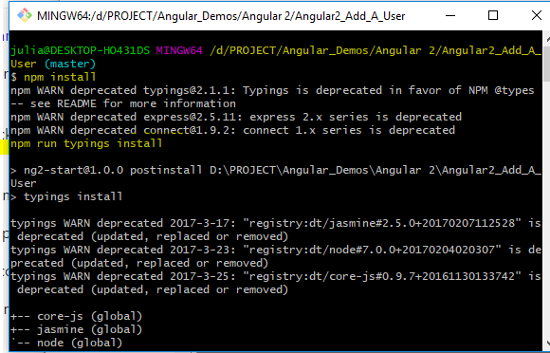

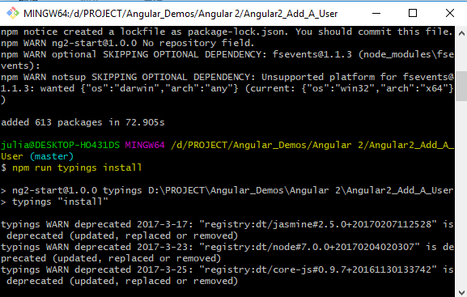

# Angular 4